Setting principles of Global Health:
In 1978 the International Conference of Alma-Ata agreed on principles to advance on the Health for all peoples, with an emphasis on the democratization of Health through the recognition that Health was to be achieved for all peoples and by all people.

Some years after the Ottawa charter acknowledged that Health was deeply related to all other policies and that it should be addressed in all policies.

From the nineties, the reference to the world’s shared Health challenges was progressively referred as Global Health, gradually replacing the term of inter-national Health and recognizing the growing diversity of factors and actors influencing the Health of all nations and peoples.

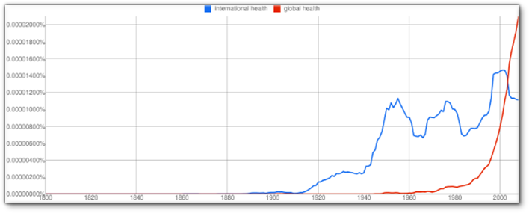
Figure 1 : Use of global Health vs. international Health in a sample of published books
The main principles of Health agreed through the major international conferences in the last thirty years may be summarized as Health for all peoples (WHO constitution 1945), by all peoples (Alma Ata 1978) and in all policies (Ottawa).
These principles, however, are not reflected in many of the Health initiatives claiming to be « global » while often restricted to some population groups or diseases –as even the Health MDGs- (not for all), by some central decisions taken vertically far from the targeted communities, in capitals or even in Geneva or New York (not by all) or focused on medical interventions and detached from structural changes in socioeconomic policies (not in all policies). Many of these not-really « global » initiatives concentrate a large share of the international resources for Health and influence the international Health agreements and commitments.
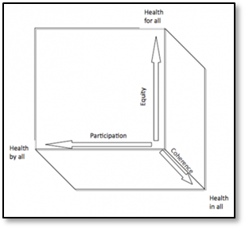
Figure 2 : Principles and vectors of global Health
The complexity of factors and actors influencing the world’s Health, together with the biased interests for some issues or groups, often prioritized in arbitrary ways and influenced more by lobbies than by evidence, are also a reflection of a weak democratic governance of international Health today.
If we’d wish nothing less for the democratic governance of Health than what we demand for a democratic government in all countries, we’d wish a democratic forum of Health representatives (Ministers of Health from democratic countries) which would gather in a parliament (World Health Assembly) and influence (according to their population weight and respecting minorities) international decisions. At present, Nauru’s vote at the World Health Assembly counts as much as China’s (with over hundred thousand times population). While minorities and small countries’ interests cannot be overshadowed by majorities or major countries, there needs to be some balance to respect the principle of equal weight of all persons in global agreements.
The resolutions proposed for this biased vote, are linked to targeted funding coming from those with greater financial capacity (hence influencing the international Health agenda) or some private groups or foundations (one being at present the largest founder of this meant-to-be international government of Health).
This is a common feature in our Washington consensus-era above mentioned where the power and freedom of movement of capital –hence called “liberal policies”-, larger than those of persons, enables the influence of a few-dominating the capital- in the lives of most. What is most striking is that the funding to work on WHO governance reform comes from the main private donor. A democratic WHO requires a budget through binding and regular contributions according to financial capacities (as in an equitable fiscal scheme).
A truly democratic World Health Assembly should aim at commitments and resolutions into programmes based on the health for all, by all and in all policies.

http://www.who.int/publications/almaata_declaration_en.pdf
http://www.who.int/healthpromotion/conferences/previous/ottawa/en/
Juan GARAY, Laura HARRIS et Julia WALSH, « Global health: evolution of the definition, use and misuse of the term », Face à face [En ligne], 12 | 2013, mis en ligne le 21 octobre 2013, consulté le 23 avril 2014. URL : http://faceaface.revues.org/745
David McCoyet al, Global health funding: how much, where it comes from and where it goes Health Policy Plan. (2009) 24 (6): 407-417 http://heapol.oxfordjournals.org/content/24/6/407
http://www.who.int/about/resources_planning/AnnexA67_43-en.pdf?ua=1
See chapter 4 of resolution 64.2 in annex 6 : Financial and administrative implications for the Secretariat of resolutions adopted by the Health Assembly http://apps.who.int/gb/ebwha/pdf_files/WHA64-REC1/A64_REC1-en.pdf#page=85

