ValyTer Ecovillage

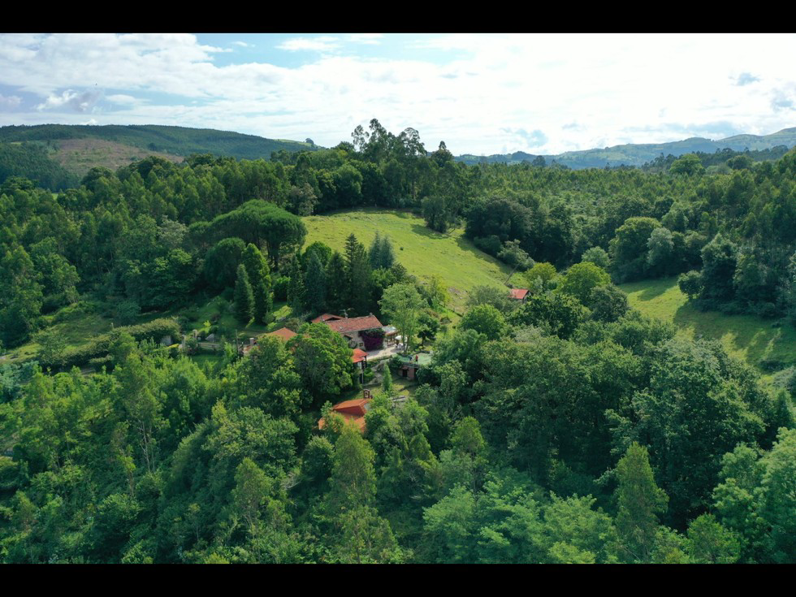

Reflections for Community Harmony with Nature

"Spiritual ecovillages kept multiplying, and every year their numbers doubled. As new members fled the collapsing system, they removed their control chips, took off their virtual glasses, looked into each other's eyes again, and regained their senses—smelling flowers and spices, witnessing sunrises, feeling the warmth of hugs. From each ecovillage, groups formed to inspire and guide others. By 2040, almost the entire world's population lived in ecovillages inspired by Umbela’s Decalogue...

Ecovillages provided, without ownership, clean water, healthy food, natural shelter, clean energy, and the most essential human need: hugs. Global collaboration provided more knowledge and a few shared global goods."

(Excerpt from the novel "Courage and Tenderness")

---

Table of Contents

I. Our Purpose

II. Values and Principles

III. Decalogue of Coexistence

IV. ValyTer’s Location

V. Design

VI. The Ecovillage in Detail

VII. Membership Process

VIII. Legal Structure

IX. Financial Structure

---

Our Purpose

"Be the change you wish to see in the world." - Mahatma Gandhi

"To be agents of change by co-creating and sharing a place of coexistence that is ecological, autonomous, and supportive."

In the gentle whisper of nature, this ecovillage project blossoms like a poetic commitment. It is born from a deep longing to be architects of change, to contribute to the creation of a society where love for the earth and humanity intertwine in an eternal dance.

We are aware that the treasures of our planetary home are not infinite. In this dreamlike corner, we want future generations to grow up nurtured by respect for nature, in harmony with resources, and free from the consumerist patterns that dominate our current society.

At our core, we long to share a simpler, more supportive lifestyle, deeply connected with the beauty, mystery, and generosity of nature and its eternal gifts.

We aim to build an ecological approach that embraces nature with care and respects life's cycles. Permaculture, as both an art and philosophy, aspires to weave ethical and sustainable human ecosystems, perfectly harmonized with the vastness of natural ecosystems.

This project invites exploration of a new model of modern and sustainable coexistence, a balm for the growing isolation of Western urban lifestyles. We dream of a world full of happiness and abundance for future generations, where sharing and global citizenship form the foundation of reality. Our goal is to be one among many lights guiding the way to a promising collective future.

On our journey, we will rely both on the wisdom passed down from our ancestors and on cutting-edge technologies that enhance efficiency and sustainability—while always being mindful of our carbon footprint. We will strive for self-sufficiency in healthy food, renewable energy, and clean water, in respectful harmony with the limits set by our beloved planet.

Thus, every step in this project becomes a declaration of love for the Earth and for future generations. In this romance with nature, we commit passionately to building a tomorrow where the whispering wind tells the story of an enduring love between humanity and its shared home.

ValyTer: A Living Poem

ValyTer, with its five hectares of meadows, forests, and orchards, is a poem that transcends words—a space where daily life merges with the very essence of being. By limiting the number of villagers and using only a fifth of the land for cultivation, housing, and paths, we prevent human overuse and respect space for other forms of life.

A common house, a central pavilion, serves as the beating heart where residents gather to cook, share, and encourage participation from neighbors and visitors. This shared haven includes spaces for play and dance, concert areas, a laundry, oven, drying room, nursery, looms, greenhouse, herbal medicine lab, library, recording studio, and other initiatives based on community consensus.

Among fruit trees and the whispers of the breeze, ValyTer maintains a balance between private spaces and the symphony of shared living. Each home, with terraces overlooking the forest, becomes a sanctuary where social bonds flourish, coexistence is a living poem, and mutual aid rises like the morning sun.

ValyTer features six communal spaces, named after virtues—Empathy, Kindness, Courage, Dreams, Soul, and Tenderness—connected by pathways named Encounter, Serenity, Joy, and Humility, standing as testaments to life in harmony with the Earth.

In the cradle of the ecovillage, the House of Tenderness welcomes visitors who wish to immerse themselves in the essence of ValyTer for short stays. These rooms serve as a refuge for both villagers and guests, offering a warm embrace of knowledge exchange and love for nature.

A Sanctuary for Nature and Life

In this green sanctuary, free-ranging chickens flutter, ruminants (to be decided) graze in serene peace, orchards whisper secrets, and permaculture unfolds as a living canvas, nurtured by rainwater and the generosity of the land.

At ValyTer, the romance with nature is eternal, and each day is a new poem written in the leaves of the trees and the murmurs of the river. In this shared paradise, the community writes its love story with the Earth, with each villager as the poet who inscribes their verses in the book of life.

---

Values and Principles

In the magical corner of ValyTer, the essence of love for the Earth intertwines with the whispers of the Cantabrian wind. This refuge knows no spiritual, religious, philosophical, or political boundaries; it is a melting pot where Courage and Tenderness take center stage in life’s great play.

The Four Core Principles of ValyTer

1. Ecosystem

We cherish the ecosystem by embracing permaculture principles and seeking balance with nature. Our commitments include sustainable energy, local materials, ecosystem restoration, protection of local wildlife and flora, eco-friendly transportation, responsible water and waste management, and food self-sufficiency.

2. Social and Cultural Bonds

We build bridges between hearts, fostering solidarity and diversity. ValyTer serves as an intergenerational and intercultural hub where ages and backgrounds intertwine. Artistic expression is encouraged, creating a community that breathes in harmony with its surroundings. We maintain a special connection with our San Antonio neighbors while welcoming visitors from all walks of life.

3. Shared Governance

At ValyTer, governance is a collective act, free from oppressive hierarchies. Every individual, regardless of age or background, has a voice and vote in daily organization and decision-making. Monthly meetings and assemblies guide our path through collective intelligence.

4. Creation and Knowledge Sharing

We are storytellers, weavers of projects that awaken consciousness, and artists in a collective creative process. Each initiative is a seed of change planted for future generations. We believe transformation begins within ourselves, with an open attitude to change, allowing us to help shape a better world.

Decalogue of Coexistence at ValyTer

Inspired by the Umbela Decalogue, this code of coexistence is woven with the subtle threads of devotion to our mother Earth, harmony with all forms of life, the love that emanates from every being, the sharing that unites our existences, the freedom that allows us to flourish, service to the common good, the empathy that connects our hearts, the compassion that eases sorrows, the constant discovery that challenges our minds, and the search for new forms of harmony in the magic of life.

1. We recognize the Earth as our mother—Gaia, Pachamama, the generator and regenerator of all life. Our primary commitment is to love, listen to, understand, feel, and care for our mother Earth, respecting her existence and the regeneration of her vital cycles, structure, and evolutionary processes. At ValyTer, we study and protect our surroundings, including its flora and fauna.

2. We honor all forms of life—human, animal, plant, and mineral—as unique and sacred. We recognize that all beings share experiences of growth and suffering and that we are interconnected. At ValyTer, no animals are sacrificed, and our diet is plant-based, relying on cultivated and wild edible species from fields and forests.

3. We recognize every human being as a unique creation with an irreplaceable message from the Earth. We live as one family with nature, sharing no greater rights than any other being. At ValyTer, people coexist without hierarchy, fostering empathy and openness toward neighbors and visitors from all origins.

4. We renounce the fear of loneliness and survival. We share physical warmth and spiritual light, working in harmony with nature to obtain shelter, food, and water. At ValyTer, personal space and belongings are respected, while common spaces and resources are shared.

5. We progressively renounce individual ownership—whether of people, land, water, life, or thought. This renunciation is an act of freedom, liberating us to live in harmony. At ValyTer, we aspire to shift from ownership to responsibility and solidarity, sharing for the common good.

6. With devotion to mother Earth, we seek to receive and feel the universe’s energy. We open ourselves to all living beings and their emotions, living in love, solidarity, and freedom. This attitude is called empathy. At ValyTer, our doors are always open to visitors, daily meals are shared with guests, and we offer support to those in need.

7. We organize and thrive as a community through collective approval. We recognize no superior or inferior beings, and all decisions arise from collective participation. We call this governance service to the common good. At ValyTer, decisions are made through daily dialogue, monthly meetings, and biannual assemblies, ensuring rotational responsibilities.

8. We resolve differences through dialogue and reflection. We reject violence and practice compassion, understanding that we all have weaknesses when we forget our shared nature. Conflict is neither good nor bad but a necessary part of change. In ValyTer, we support each other in times of distress, using nonviolent conflict resolution tools like sociocracy and holocracy.

9. We seek new ways to harmonize with nature by transforming pain into joy and expanding our understanding of existence. We challenge the mind through constant discovery, not believing ourselves superior to the past but flowing into new ways of living in balance. At ValyTer, artistic and creative expression is encouraged in all forms—music, storytelling, visual arts—to enrich the soul and foster empathy.

10. We live as part of a new humanity—a community of communities. We recognize ourselves as part of a great human family, embracing exchanges and unity in harmony with the universe. At ValyTer, we engage with global networks promoting coexistence free from ownership, hierarchies, absolute truths, borders, and the fear of love.

---

ValyTer’s Location

Located in San Antonio, Entrambasaguas (Cantabria, Spain), ValyTer spans five hectares of nature, nestled in the Miera River basin, southeast of Santander.

This land is home to:

Three hectares of forests with oaks, ashes, holly, walnuts, hazelnuts, beeches, laurels, cork oaks, willows, chestnuts, and acacias

A rich wildlife, including robins, doves, blackbirds, deer, foxes, wild boars, otters, and countless insects

Two hectares of meadows for permaculture gardens, fruit orchards, and grazing land

ValyTer is well connected to urban areas via buses and trains:

2 km from Entrambasaguas (health center, bakery, pharmacy, schools, cultural center)

7 km from La Cavada, with a train station linking to northern Spain

Less than 30 minutes from Santander’s university, hospital, and airport

---

Design and Governance

ValyTer was founded by 27 people, forming a nonprofit association to apply for public funding and promote ecological knowledge and conservation.

The membership process is outlined in a separate document, defining entry, exit, and community roles.

The community follows horizontal governance, where all members, including children, participate in decision-making. Meetings are held:

Monthly (for tasks and initiatives)

Biannually (for assemblies on major decisions)

---

Permaculture and Circular Economy

ValyTer follows permaculture principles, integrating horticulture, animal husbandry, and natural waste management to:

Reduce environmental impact

Recycle organic waste through composting and dry toilets

Harvest and store rainwater

Use solar energy (10 kW from 70 m² of panels)

Animals live freely, contributing to ecosystem balance. Chickens, sheep, and ducks help regulate pests and fertilize the land. No animals are harmed, and domestic pets are cared for in harmony with local wildlife.

---

End of Life and Natural Burial

When Spanish law permits, ValyTer plans to offer natural burials in the forest, using biodegradable niches and planting trees as living memorials. Outdoor rituals will celebrate life’s cycles, honoring the deceased while nurturing the ecosystem.

Every community member will determine their end-of-life wishes, ensuring a dignified and loving farewell.

---

Legal and Financial Structure

ValyTer is a registered nonprofit in Cantabria, dedicated to environmental education and sustainable living.

Financial sustainability is maintained through:

Membership contributions

Public and private grants

Eco-tourism, workshops, and cultural events

Revenue reinvested into community projects

---

Conclusion

ValyTer is more than an ecovillage—it is a manifesto of love for the Earth. Every path, every home, every action is a poetic commitment to a harmonious future.

In a world increasingly marked by violence and division, each resident of ValyTer strives to embody peace within and beyond, radiating a vision of humanity that respects nature, fosters empathy, and defends human rights.

ValyTer, August 4, 2024

---